**Career Paths**

**Web Design and Development**

**WDD100**



<https://youtu.be/jIj6Nid8ynI>

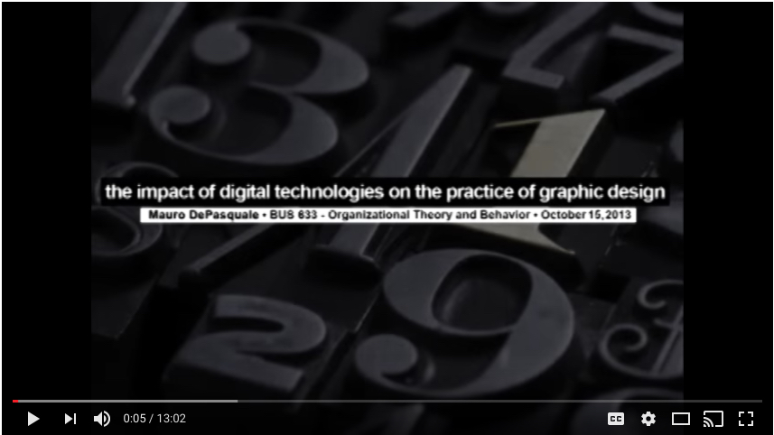

<https://youtu.be/IV57vp7VVA0>

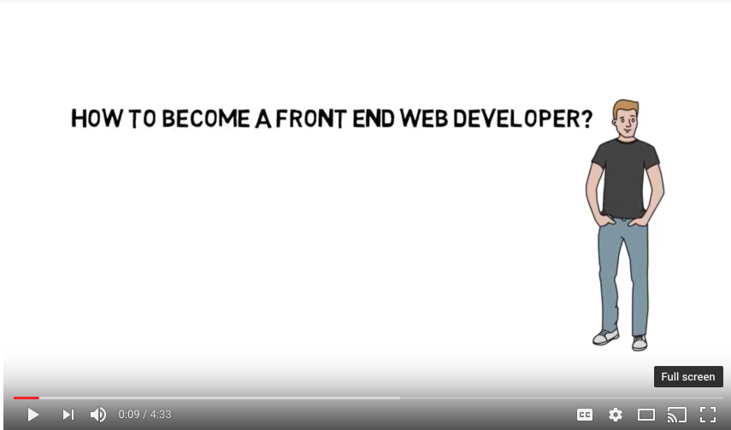

<https://youtu.be/M-M7jBV_Gf4>

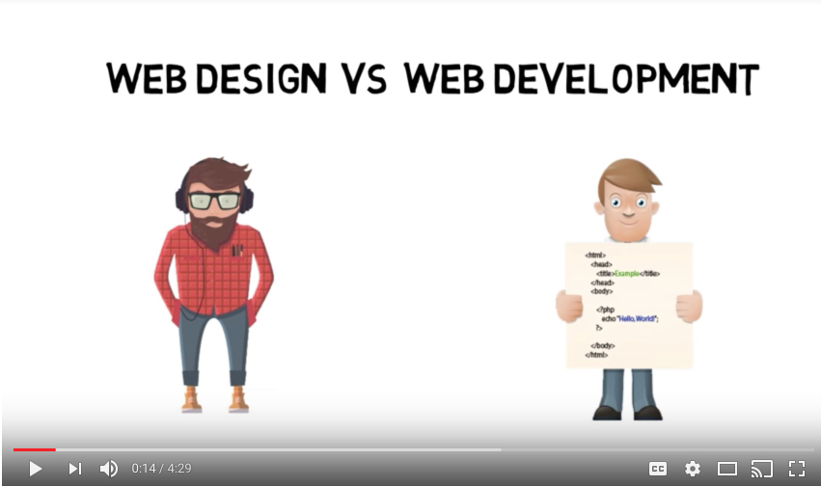

<https://youtu.be/oxfE2SXIILI>

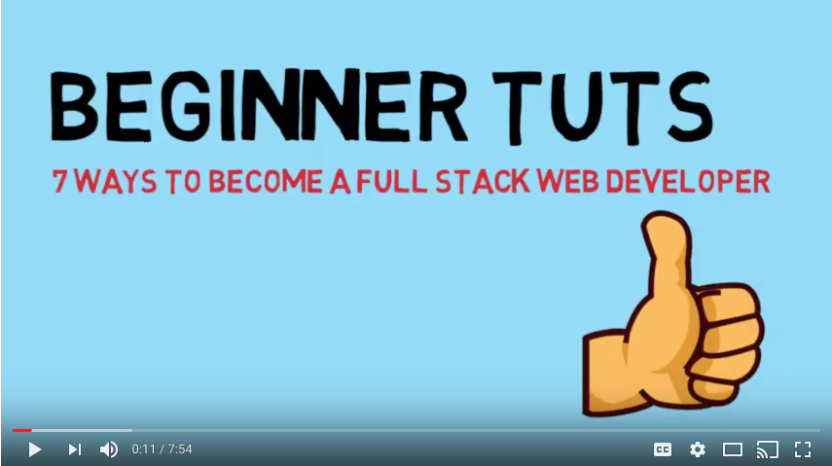

<https://youtu.be/eUfGBbPWw5o>



<https://youtu.be/FZzWGr3ruVw>



<https://youtu.be/M-M7jBV_Gf4>

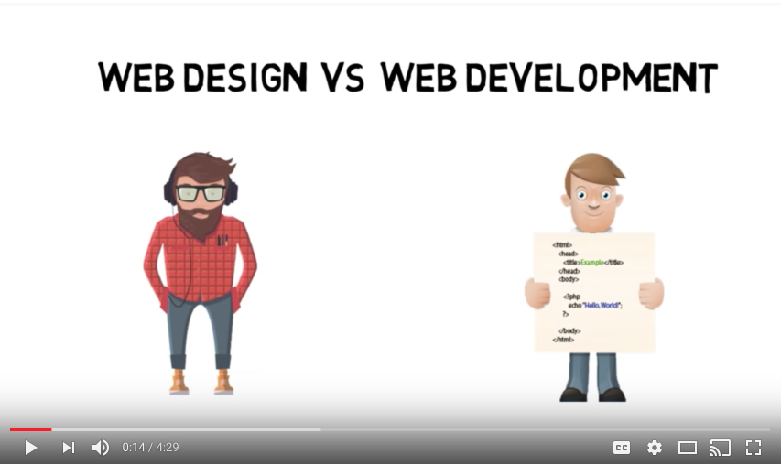

<https://www.youtube.com/watch?v=5YQkWQbDS9w>

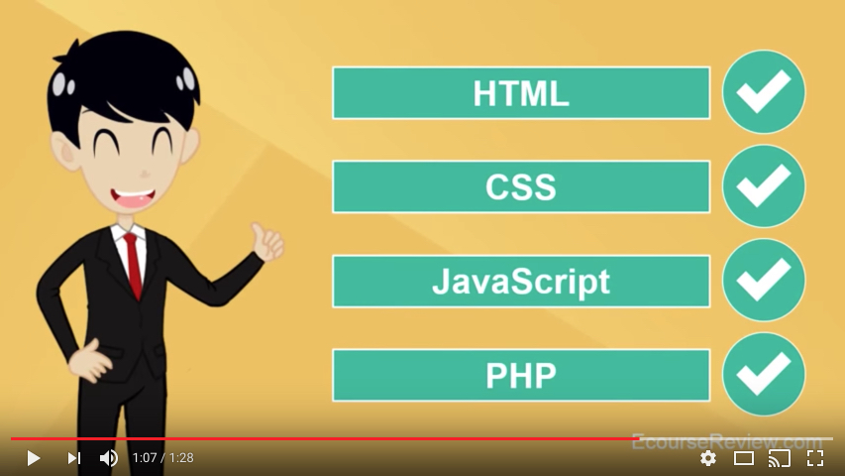

<https://youtu.be/gQRsgFw7tcg>



<https://www.youtube.com/channel/UCL0iAkpqV5YaIVG7xkDtS4Q?v=QI272Yrk33Q>

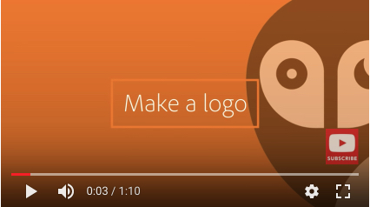

<https://www.youtube.com/watch?v=eZmbfikc3NI>

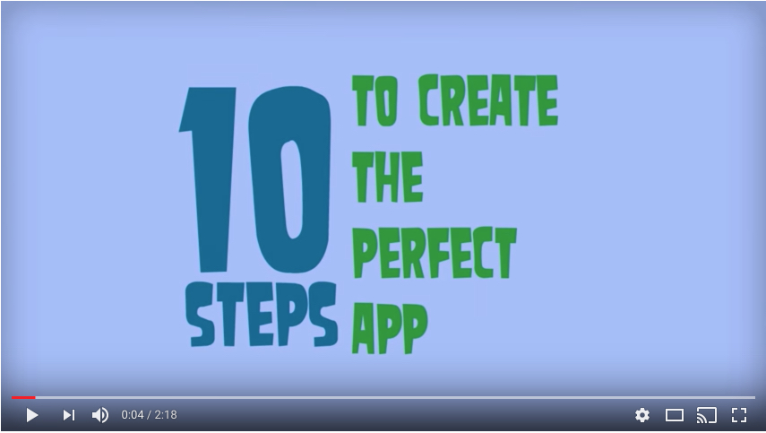

<https://www.youtube.com/watch?v=FXqTHsPaY0A>

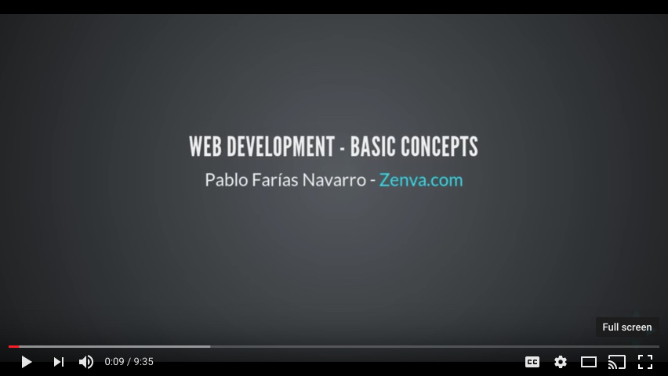

<https://www.youtube.com/watch?v=75sFVJ1fPpU>

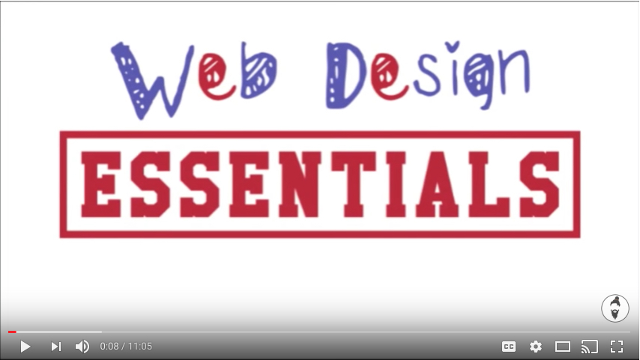

<https://www.youtube.com/watch?v=3J85SUZFXNM>

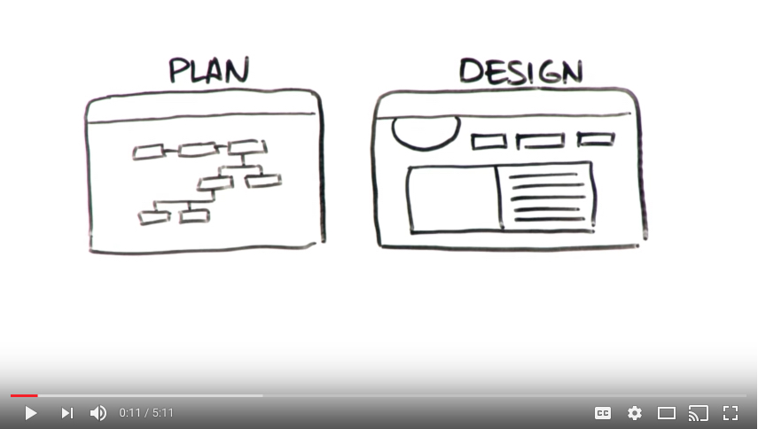

<https://www.youtube.com/watch?v=JxDtzLW6eVg>

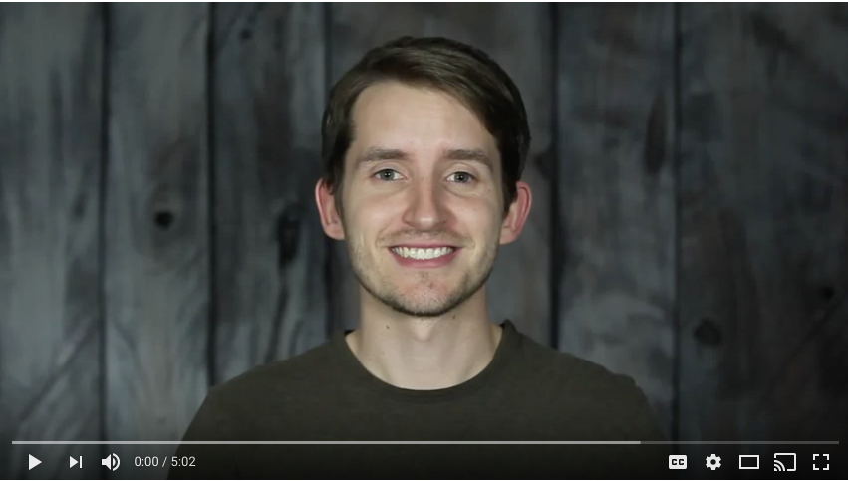

<https://www.youtube.com/watch?v=_2LLXnUdUIc>

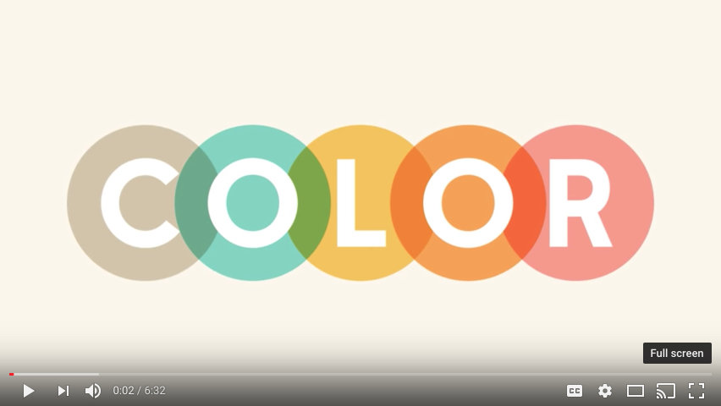

<https://www.youtube.com/watch?v=sByzHoiYFX0>

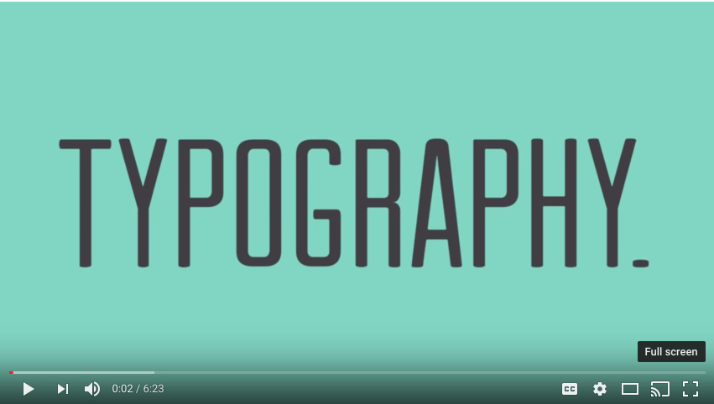

<https://www.youtube.com/watch?v=MELKuexR3sQ>



<https://www.youtube.com/watch?v=a5KYlHNKQB8>

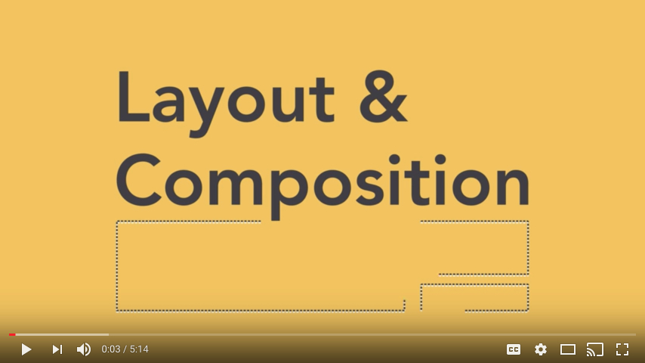

<https://www.youtube.com/watch?v=y_FBvzbgnT8>

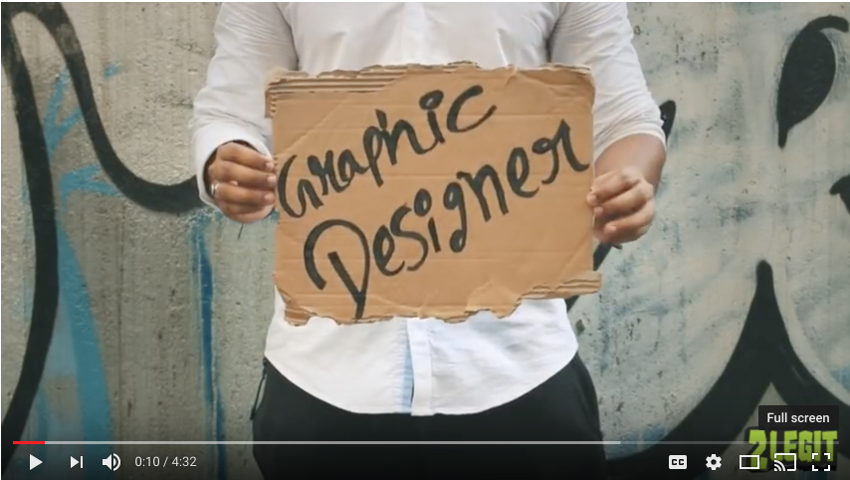

<https://www.youtube.com/watch?v=l-S2Y3SF3mM>



<https://www.youtube.com/watch?v=YqQx75OPRa0>

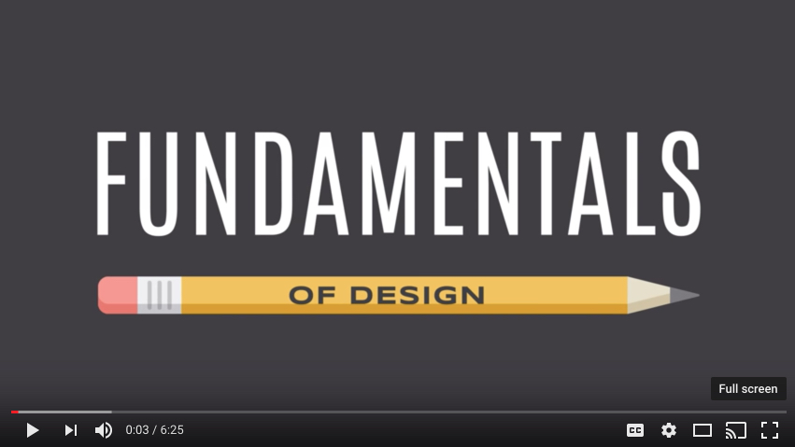

<https://www.youtube.com/watch?v=88Nfvg38nzs>

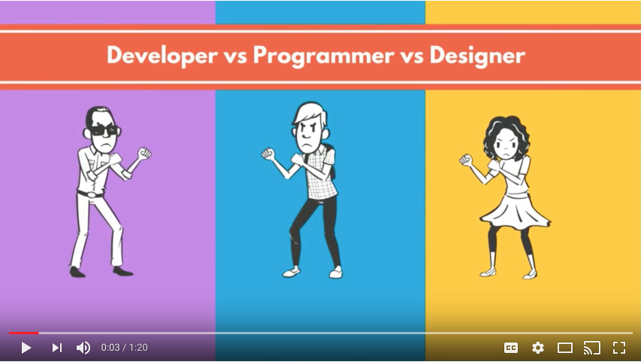

<https://www.youtube.com/watch?v=CJnH3uMrFU4>



<https://www.youtube.com/watch?v=Gj3hD2XqPpY>

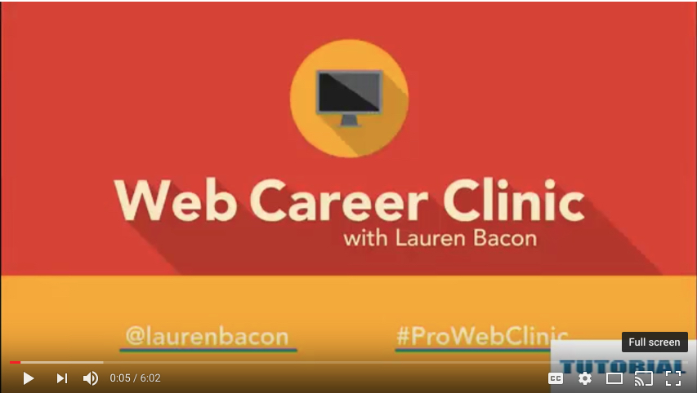

<https://www.youtube.com/watch?v=wJXc2WJzi_o>



<https://www.youtube.com/watch?v=8-vTd7GRk-w>

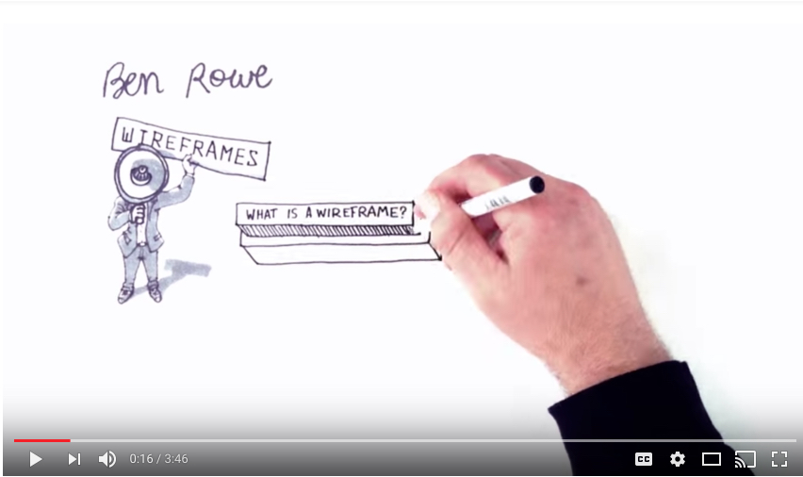

<https://www.youtube.com/watch?v=78MGzBNHn8k>



<https://www.youtube.com/watch?v=W1kw5xK1C30>



<https://www.youtube.com/watch?v=pjUeWOB-9RY>

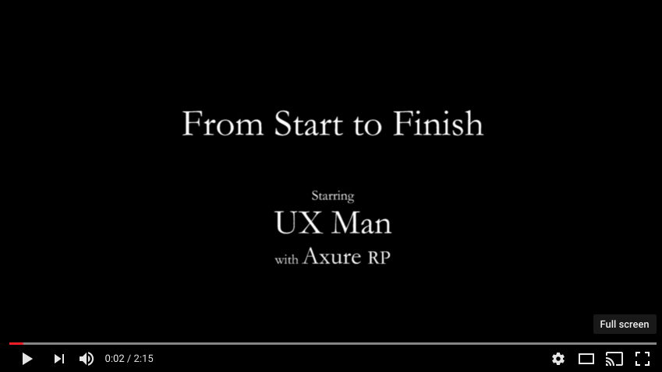

<https://www.youtube.com/watch?v=1H7Ql9hmbuM>

